Go for the Gold – Olympics Quilt

Quilt finishes 80 x 92

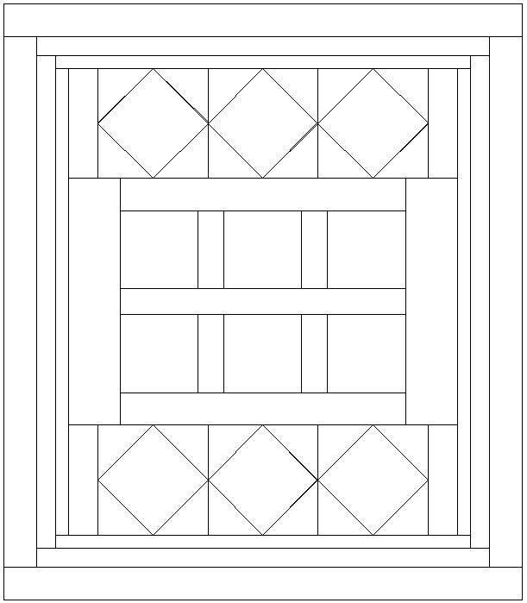
64-1/2” x 2-1/2”
70-1/2” x 3-1/2”
A
A
A
A
A
A
A
A
A
A
A
A
A
A
A
A
A
A
A
A
A
A
A
12-1/2” x 4-1/2”
12-1/2” x 4-1/2”
12-1/2” x 4-1/2”
12-1/2” x 4-1/2”
38-1/2” x8-1/2”
17-1/2 x 5
”
17-1/2” x 5”
”
17-1/2 x 5
”
17-1/2” x 5”
”
38-1/2” x8-1/2”
44-1/2” x 4-1/2”
44-1/2” x 5-1/2”
44-1/2” x 5-1/2”
64-1/2” x 2-1/2”
70-1/2” x 3-1/2”
72-1/2” x2-1/2”
72-1/2” x 2-1/2”
76-1/2” x 3-1/2”
76-1/2” x 3-1/2”
82-1/2” x 5-1/2”
82-1/2” x 5-1/2”
A
80-1/2” x 5-1/2”
80-1/2” x 5-1/2”
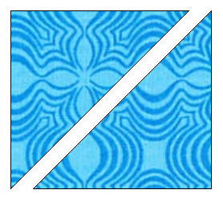
A - 9-3/8”□, Cut once on diagonal for 2 triangles.
